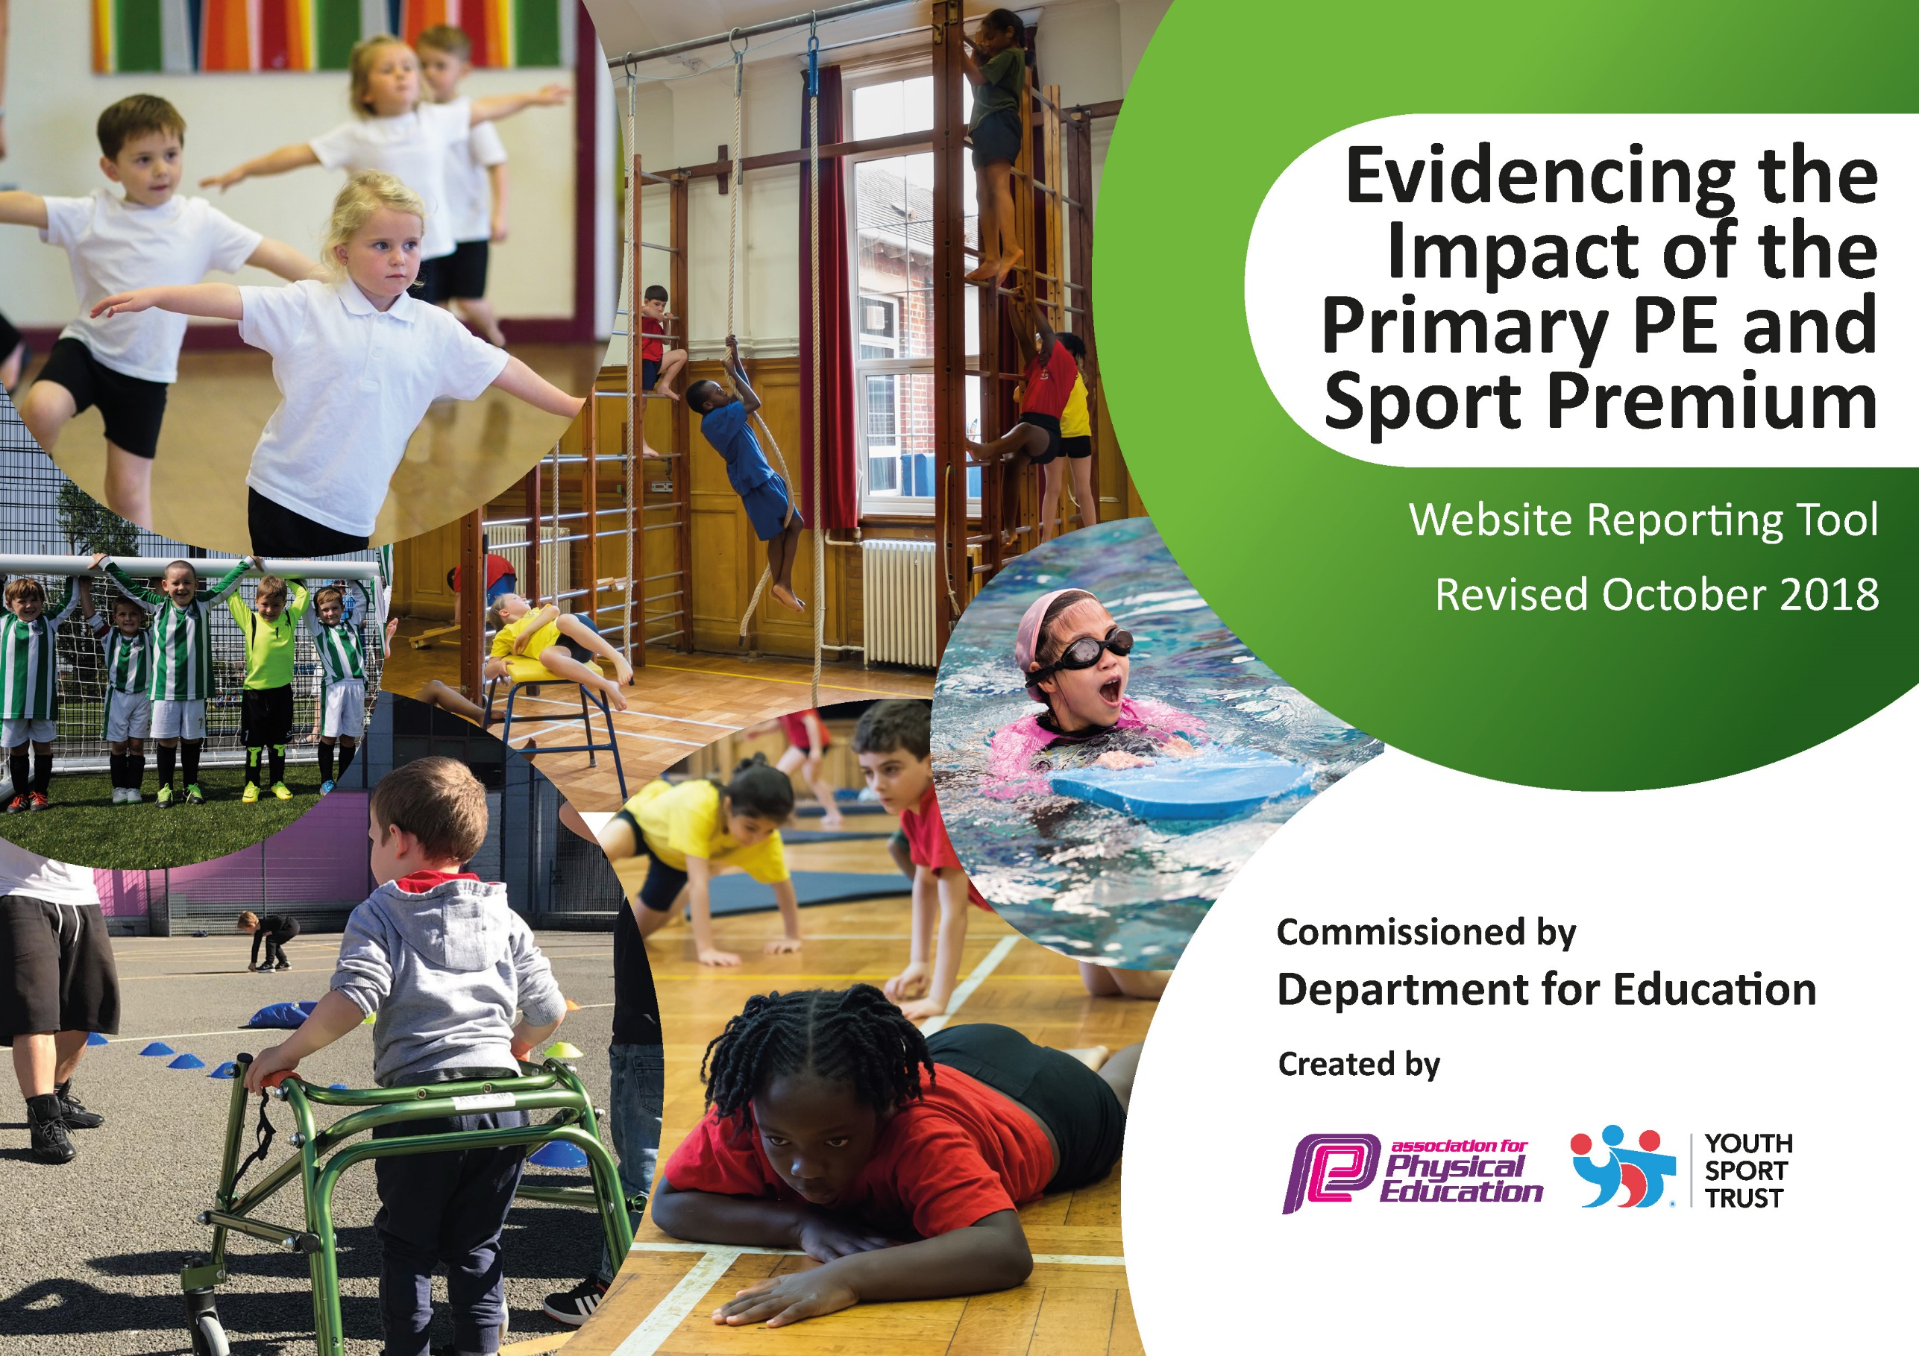
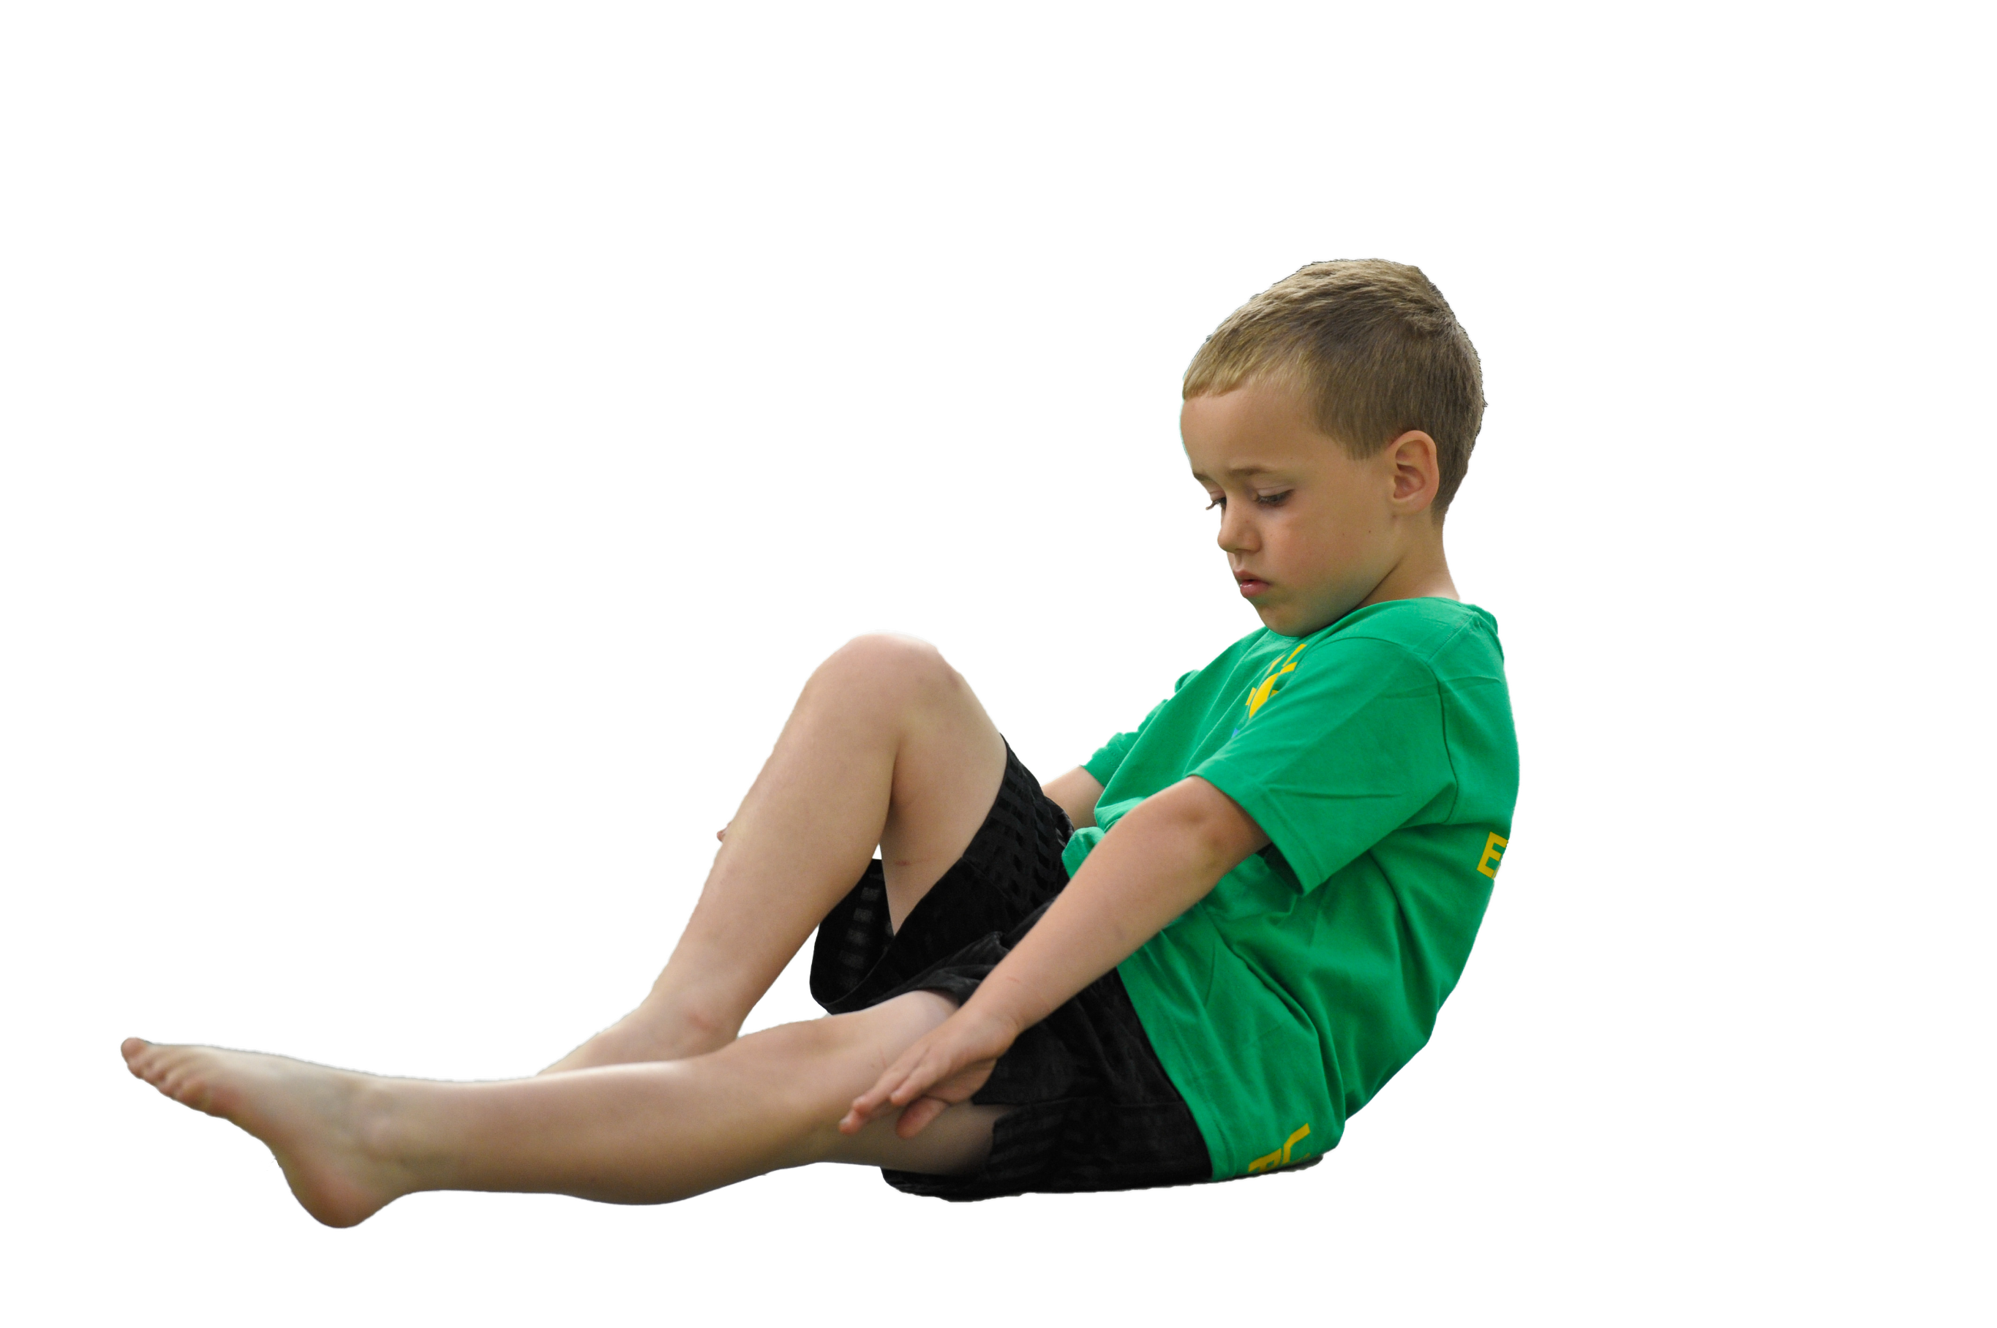
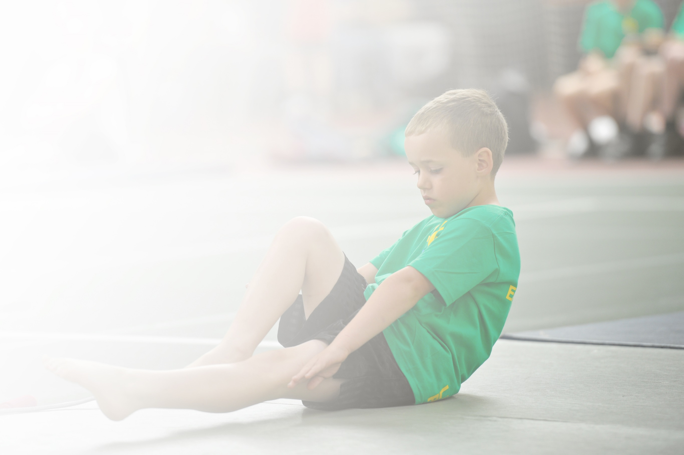
Schools must use the funding to make additional and sustainable improvements to the quality of Physical Education, Sport and Physical Activity (PESPA) they offer. This means that you should use the Primary PE and Sport Premium to:

- Develop or add to the PESPA activities that your school already offer
- Build capacity and capability within the school to ensure that improvements made now will benefit pupils joining the school in future years

Please visit gov.uk for the revised DfE guidance including the 5 key indicators across which schools should demonstrate an improvement. This document will help you to review your provision and to report
your spend. DfE encourages schools to use this template as an effective way of meeting the reporting requirements of the Primary PE and Sport Premium.

We recommend you start by reflecting on the impact of current provision and reviewing the previous
spend. Under the Ofsted Schools Inspection Framework, inspectors will assess how effectively leaders use the Primary PE and Sport Premium and measure its impact on outcomes for pupils, and how effectively governors hold them to account for this.

Schools are required to publish details of how they spend this funding as well as on the impact it has on pupils’ PE and sport participation and attainment by the end of the summer term or by 31 July 2019 at the
latest.
We recommend regularly updating the table and publishing it
on your website throughout the year, as evidence of your
ongoing review into how you are using the money to
secure maximum, sustainable impact. To see an
example of how to complete the table please
click HERE.

Support for review and reflection - considering the 5 key indicators from DfE, what development needs are a priority for your setting and your students now and why? Use the space below to reflect on previous spend, identify current need and priorities for the future.

Key achievements to date: | Areas for further improvement and baseline evidence of need:
Participation in competitive sport. Each year, we sign up to be part of the Birmingham Catholic Schools Sports Association and take part in various competitions (athletics, swimming, football, netball, cross-country) both within school and against other local schools.  Broader Experience of a range of sports and activities offered to all pupils. During curriculum P.E, the children experience a wide range of sports and activities, planned by the P.E coordinator. Multi-sports clubs are offered to all children from Year 1 to Year 6. In these sessions, the children are exposed to a wide variety of sports and activities. Netball and football after-school clubs are held weekly and fortnightly respectively. All children have weekly dance sessions. In addition to this, we often have specialist coaches visit school to deliver sessions on various sports. In previous years we have had tennis, Gaelic football and rugby coaches deliver progressive sessions that spanned for eight weeks and were enjoyed by a variety of different classes. | The engagement of all pupils in regular physical activity.  As a school, we have identified that a proportion of our children are inactive and/or overweight. The Government Childhood Obesity Plan has set out the ambition for all children to achieve 60 minutes of physical activity every day, with schools being responsible for delivering 30 of these active minutes.  Increased confidence, knowledge and skills of all staff in teaching P.E and sport  We have a proportion of young staff who received very little P.E training prior to becoming a teacher and consequently lack confidence in certain areas.  The profile of P.E and sport is raised across the school.  As a school, we do commend sporting achievements during assemblies and P.E and Sport is present in what we say and do. However, there is room for improvement here.

Meeting national curriculum requirements for swimming and water safety | Please complete all of the below:
What percentage of your current Year 6 cohort swim competently, confidently and proficiently over a distance of at least 25 metres?  N.B. Even though your children may swim in another year please report on their attainment on leaving  primary school. | 62%
What percentage of your current Year 6 cohort use a range of strokes effectively [for example, front crawl, backstroke and breaststroke]? | 62%
What percentage of your current Year 6 cohort perform safe self-rescue in different water-based situations? | 62%
Schools can choose to use the Primary PE and Sport Premium to provide additional provision for swimming but this must be for activity over and above the national curriculum requirements. Have you used it in this way? | No

Action Plan and Budget Tracking
Capture your intended annual spend against the 5 key indicators. Clarify the success criteria and evidence of impact that you intend to measure to evaluate for students today and for the future.

Academic Year: 2018/19 | Total fund allocated: £19,610  Total amount spent: £23,982 |  |  | Date Updated: July 2019
Funding allocated*
The funds allocated for the academic year totalled £19, 610.
In April 2018 to August 2018, this was used to the PE Lead’s salary cost [50% of MPS6 and 50% TLR2a).
This worked out as follows:
Sept 18 – Mar 19 at £14,172
Apr 19 – Aug 19 at £9,775
This totalled at £23,947.
An additional £35 was spent on an annual safety check of PE equipment.

Therefore, in additional to the Sports Premium of £19,610, we have spent an additional £4372, which came from school budget share.
Key indicator 1: The engagement of all pupils in regular physical activity – Chief Medical Officer guidelines recommend that primary school children undertake at least 30 minutes of physical activity a day in school |  |  |  |  |  |  | Percentage of total allocation:
 |  |  |  |  |  |  | 0 %
School focus with clarity on intended impact on pupils: | Actions to achieve: |  |  | Funding allocated: | Evidence and impact: |  | Sustainability and suggested next steps:
As a school, we have identified that a proportion of our children are inactive and/or overweight. The Government Childhood Obesity Plan has set out the ambition for all children to achieve 60 minutes of physical activity every day, with schools being responsible for delivering 30 of these active minutes.  The impact should be that all pupils become fitter and healthier through regular exercise but the targeted children (identified above) engage in activity leading to better individual health and fitness. | To address the target of 60 minutes a day being active, we have signed up for and introduced ‘The Daily Mile’.  The children use 15 minutes in the afternoon to go outside and run a mile each day, in addition to their morning break (15mins) and lunch break (60mins)  Additionally, the school intends on holding a week dedicated to health and fitness in the Spring term. This will be a week devoted to encouraging the children and parents to stay fit and healthy. (Health and Fitness Week was held Feb 2019) |  |  | £0* | Pupil questionnaires have evidenced that children feel positively about ‘The Daily Mile’ and we are confident that we are delivering in excess of thirty minutes a day when the time for the Daily Mile is added to two hours of PE curriculum time.  Do you enjoy taking part in ‘The Daily Mile’?  Year 3: 85% yes  Year 4: 91% yes  Year 5: 100% yes  Year 6: 90% yes  Do you feel that you do 1 hour of physical activity every day?  Year 3: 65% yes  Year 4: 69% yes  Year 5: 85% yes  Year 6: 86% yes |  | This initiative should continue into next year.  A next step: KS2 year groups to pair with KS1 year groups in order to encourage the younger children to build endurance.  The Health and Fitness Week was a success and SMT have timetabled a week in the academic year 2019/20 where this will take place again, partly funded by Sports Premium.  An additional healthy outcome was the introduction of ‘Meat-free Monday” which came as a direction consequence of Health and Fitness Week.
Key indicator 2: The profile of PESSPA being raised across the school as a tool for whole school improvement |  |  |  |  |  |  | Percentage of total allocation:
 |  |  |  |  |  |  | 0 %
School focus with clarity on intended impact on pupils: | Actions to achieve: |  |  | Funding allocated: | Evidence and impact: |  | Sustainability and suggested next steps:
As a school, celebrate each and every sporting achievements during assemblies.  By further enhancing the profile of sport and PE, we hope to see children who might not be as willing to engage in sporting activities start to feel more involved and be more active. | A half termly assembly where all sporting achievements are commended. Children who have achieved in any area of sport or activity will bring in certificates, medals etc. and speak briefly about their achievement. Parents to be invited to attend.  To make sure that our Twitter feed and school website informs and highlights all the sport and activity we are doing in school. Information about the daily mile, information about healthy lifestyles competitions taking place.  Create a display of awards in the hall or school foyer. |  |  | £0* | We have seen an increase in the amount of children who are presenting their sporting achievements in whole school assemblies.  During ‘Health and Fitness’ week children worked with local clubs (Tennis, Gymnastics, Dance, Volleyball, Yoga). Feedback from these providers suggests that children have taken up new sports as a result of this.  Pupil Voice from ‘Health and Fitness Week’ was incredibly positive with children suggesting they will make positive changes as a result.  One child wrote: “I will change my lifestyle because of healthy week. I will eat healthier and exercise harder in my karate class.” |  | Make ‘Health and Fitness Week’ an annual event.  Use website to promote/signpost additional Sports Clubs (e.g. Orion Swimming, Harborne Cricket, Harborne Hockey, Bournville Rugby Club)  Bournville Rugby Club to deliver Multisports clubs in 2019/20 four days a week.
Key indicator 3: Increased confidence, knowledge and skills of all staff in teaching PE and sport |  |  |  |  |  |  |  | Percentage of total allocation:
 |  |  |  |  |  |  |  | 100 %
School focus with clarity on intended  impact on pupils: |  | Actions to achieve: | Funding  allocated: |  |  | Evidence and impact: |  | Sustainability and suggested  next steps:
We have a proportion of young staff who received very little P.E training prior to becoming a teacher and consequently lack confidence in certain areas.  By increasing staff confidence, the effectiveness of the lessons will improve, which, in turn, will have a positive impact on children’s learning. |  | Highly-trained PE Lead to take the responsibility for curriculum review, coaching and CPD, extending school provision, updating the environment, and taking after school multi-sports sessions.  Teachers to work closely with P.E coordinator to ensure that they are confident to deliver all aspects of P.E lessons that demonstrate impact and progression.  NQTs to meet with PE Lead to discuss planning, teaching and assessment.  Raise standards and the profile of sport across the school, further encouraging healthy and physically active lifestyles. | £19, 610  (and further supplemented from SBS) |  |  | Data from assessments suggests that there has been a rise in the percentage of children making further progress this year in 9 out of 12 classes demonstrating a rise in standards across the school.  Through teacher questionnaires, it is clear that teachers’ confidence has risen which has a positive impact on progression and attainment in P.E.  Teachers now able to plan and deiver whole schemes of lessons in accordance to curriculum due to high quality support provided by PE Lead. |  | Continue to assess PE so staff are aware a) content of the curriculum, and b) how skills can be built upon.  Questionnaire to be filled out by staff to identified areas in own professional development to be built upon.  Liaise with secondary PE teachers at Tolkien Cluster schools to ensure professional development and subject knowledge of staff is being adequately delivered.
Key indicator 4: Broader experience of a range of sports and activities offered to all pupils |  |  |  |  |  |  |  | Percentage of total allocation:
 |  |  |  |  |  |  |  | 0 %
School focus with clarity on intended  impact on pupils: |  | Actions to achieve: | Funding  allocated: |  |  | Evidence and impact: |  | Sustainability and suggested  next steps:
Additional achievements:  Through health and fitness week, children have been exposed to lots of new sports and this will continue to be a focus for children next academic year 2019/20. |  | Ensure children have opportunity to pursue new sports by contacting specific providers. | £0* |  |  | As part of their taught PE curriculum, staff (working with PE Lead) deliver the following units:  Invasion Games (Rugby, football, netball)  Net and Wall Games (tennis and badminton)  Striking and Fielding Games (e.g. cricket and rounders)  Gymnastics  Dance (1 hr per week)  Swimming (Year Two, Four and Six – one term each) |  | Health and Fitness week in Spr Two term 2019/20.  AHT to oversee.
Key indicator 5: Increased participation in competitive sport |  |  |  |  |  |  |  | Percentage of total allocation:
 |  |  |  |  |  |  |  | 0 %
School focus with clarity on intended  impact on pupils: |  | Actions to achieve: | Funding  allocated: |  |  | Evidence and impact: |  | Sustainability and suggested  next steps:
Ensure that children are involved in competitive sport. |  | Increase this percentage annually so more children have opportunity. | £0* |  |  | Selection of G&T children took part in competitive sport  School football via AVFC tournament and BCSSA.  Netball matches for Year Five and Six  Chess matches and tournaments |  | Continue to develop BCSSA links with football, rugby, cross country, netball, rounders and cricket a priority.  This target will be carried forward for next academic year.

